Contact: Sharon Cordero, Administrative Assistant
Telephone: (978) 772-4627 x300

FOR IMMEDIATE RELEASE
Email: office@loavesfishespantry.org

Loaves & Fishes 6th Annual
Fundraiser Golf Tournament
Raises $9,200

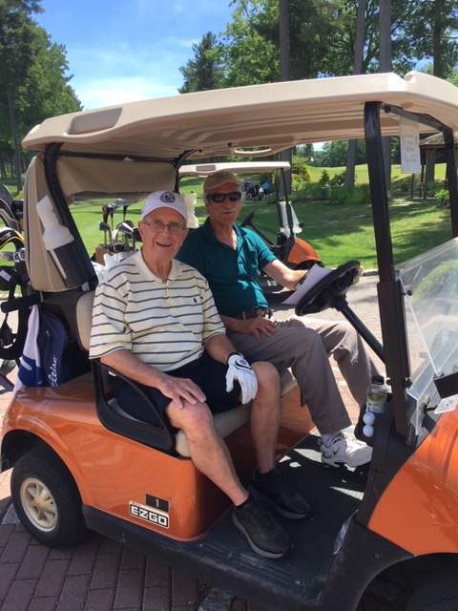
The Loaves & Fishes 6th Annual Golf Tournament, which took place on June 10 at Shaker Hills Country Club, was co-sponsored by Catania Oils (Ayer) and Wilson Brothers HVAC, Inc. (Pepperell). We had a great turnout, lots of fun, and we raised more than $9,200.

100% of the net proceeds from the tournament goes directly to the Loaves & Fishes Food Pantry which exists as a mission to provide nutritious food in an atmosphere of kindness and respect to residents of Ayer, Devens, Dunstable, Groton, Harvard, Littleton and Shirley.

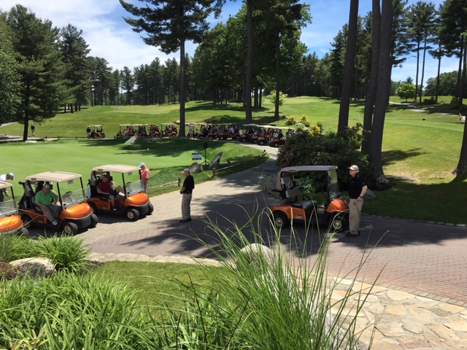
In addition to the co-sponsors, the following companies and individuals provided sponsorships: Acton Toyota (which sponsored the Hole-in-One contests), Epic Enterprises, Inc., Main Street Bank, Enterprise Bank, Rich & Edie Baker, Great Road Farm & Garden, , Dunkin’ Donuts (Ayer), Robert C. Alario, CPA, PC, Law Office of Aleta Manugian , Kimball Farms, Catalano Enterprises, Reddy Family Dental, Spavia Day Spa (Littleton), The Lexvest Group, Rev. Peter Quinn, MRM Associates, Avidia Bank, State Senator Jamie Eldridge, Alexander Advisors, LLC, Wes & Madeleine Baker, United Steel Workers of America—Local 0506 (Bemis Associates), Rollstone Bank & Trust, Harvard Outdoor Power Equipment, Moison Ace Hardware, UBS Financial Services, Inc., Connie Sullivan, Attorney-At-Law, and the Blackley Family Foundation.

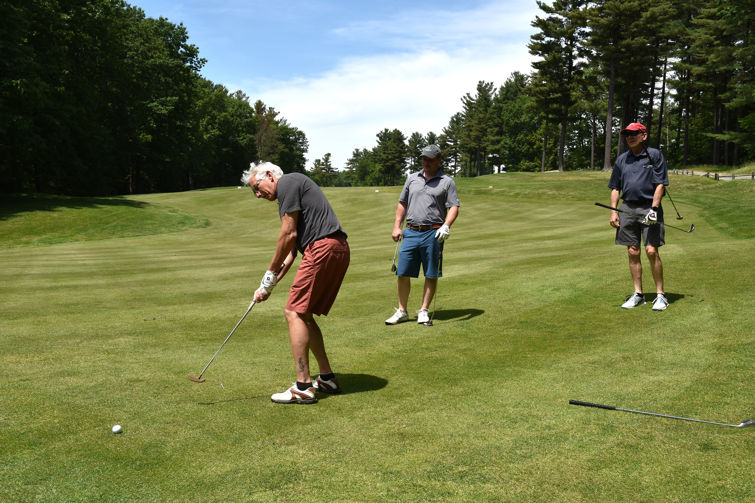
Donors who contributed raffle items or auction items included: The Groton Inn, The New England Patriots, The Boston Celtics, Main Street Bank, Wilson Brothers, Title Boxing Club, Loyal Companion, D’Ambrosio Eye Care, Colonial Spirits, Flowers by Stella, Wok-‘N- Roll, The Lexvest Group, The Billiards Café, The Cottage Restaurant, The Vineyard, Filho’s Cucina, The Boston Red Sox, Westford Wine & Spirits, Taka Restaurant, David Cook, Country Butcher & Deli, Groton Market, Lavendar, Bodylines Pilates, Shawn Campbell, Gibbet Hill Grill, Indigo, Joanne Ouellette & Kathy Raftery, The Notch Hostel, Tavern in the Square, O’Neil Cinemas, Hair Cuttery, Starbucks, Anthony’s Coal Fired Pizza, Catania Oils, Jack O’Lantern, Lowell Spinners, Denise & Kevin Boyd, Great Road Farm & Garden, Stan & Michelle Swearingen, The Lexvest Group, and SoVital Fitness Studios.

Special thanks to Joanne Ouellette and her crew of volunteers who helped make the entire event run so smoothly.

To the Loaves & Fishes community, Thank You for your continued and generous support.

Jim Hanlon
Tournament Coordinator

